 **GO-STANDARD NURSERY & PRI-SCHOOL**

**END OF YEAR EXAMINATION 2023**

**MIDDLE CLASS: (4 – 5 YEARS)**

**LEARNING AREA 3: HEALTH HABITS**

**My name is: ……………………………………………………………….**

**My School is: …………………………………….………………………..**

**I am in: ………………………………..…………………………….…………………..**

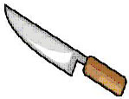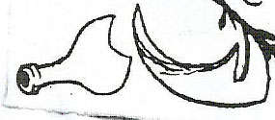I. **Match and name the dangerous objects.**

___________

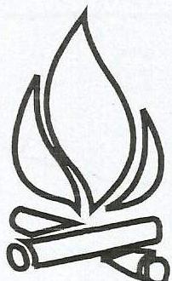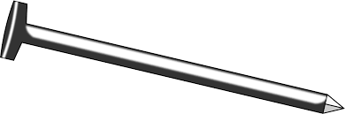 ___________ ___________ ___________

___________

(fire , stone, broken bottle, nail, knife)

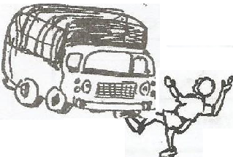2. **Name these accidents.**

**_______________________**

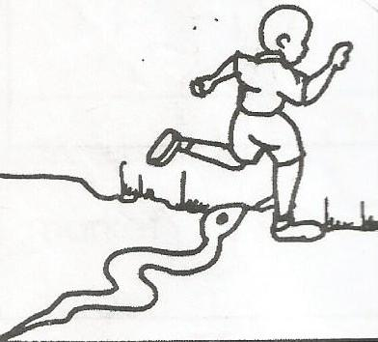

**______________________**

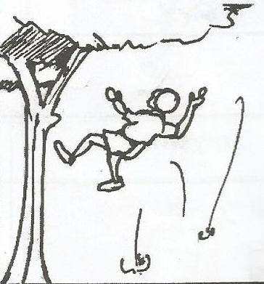

**_______________________**

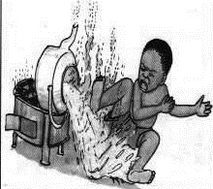

**________________________**

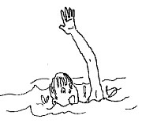

**_________________________**

(snake bite, burn, fall, drowning, knock)

3. **Oral work**.

**Tell these sources of light.**

D:\Local Disk F\New folder\KIBUUKA 2023\pictures\DISAN PICS\pics PART 2\pics\candle lij.jpg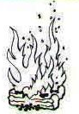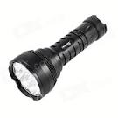

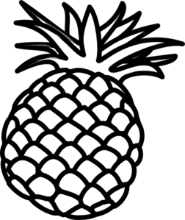4. **Shade this fruit.**

3. Shade this living thing

5. **Match the fruits to their names.**

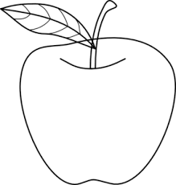

banana

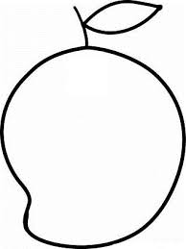

orange

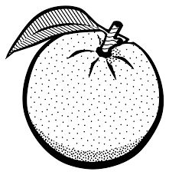

pineapple

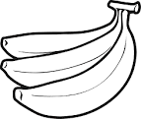

apple



mango

**END**